Oklahoma school replaces chalkboards
When contractors began work on four classrooms of Emerson High School in Oklahoma, they knew their remodel would improve education — but they never expected it would impact local history.
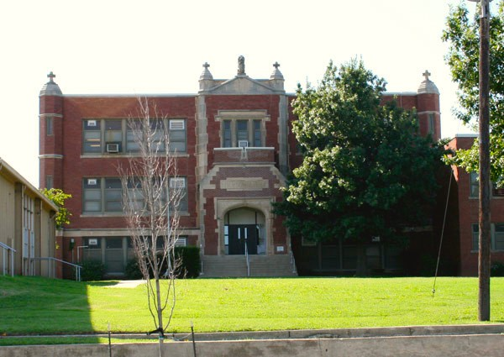
Looking to upgrade the rooms with new whiteboards and smartboards, the workers had to first remove the outdated chalkboards. But when they began to pull away the old boards, they made a startling discovery
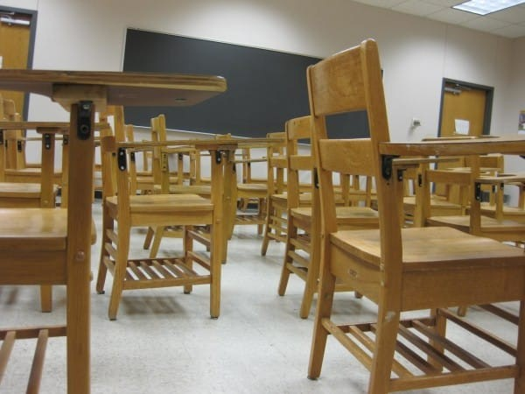
Beneath the current boards rested another set of chalkboards — untouched for nearly 100 years. Protected and totally undisturbed, the century-old writings and drawings looked like they were made just yesterday. Here, a November calendar rolls into December. A turkey marks the celebration of Thanksgiving.
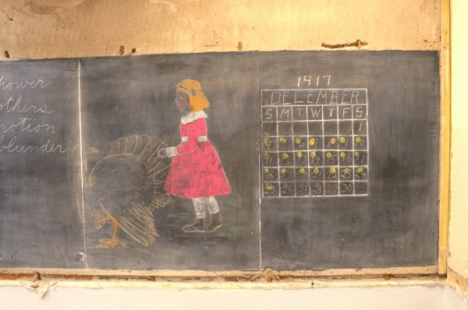
A multiplication table gives us a glimpse into the curriculum and methods taught in 1917 techniques perhaps lost in the passage of time. When regarding a wheel of multiplication, Principal Sherry Kishore told The Oklahoman, “I have never seen that technique in my life.”
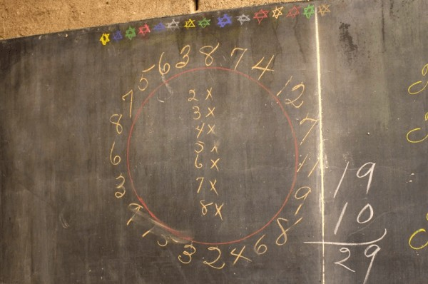
But Oklahoma City school officials aren’t just shocked by what is written, but how it is written. Penmanship like this is clearly a lost art. This board reads, “I give my head, my heart, and my life to my God and One nation indivisible with justice for all.”
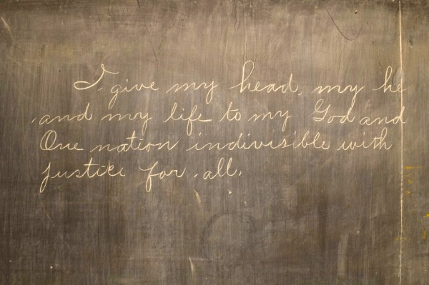
Within each of the four rooms, the subject matter and lessons mirrored one another — indicating, as an Oklahoma Public School Twitter caption reads, “aligned curriculum in 1917.”
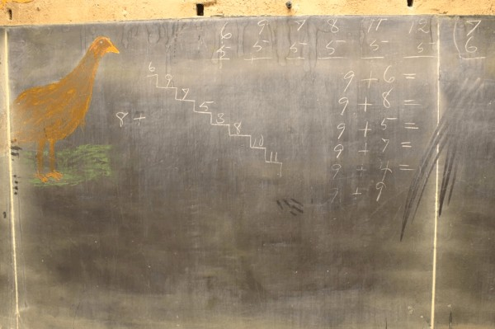
And though the boards’ style and subject matter might be unfamiliar to younger folks, they certainly resonate with older generations. Principal Kishore told The Oklahoman what it was like to show her 85-year-old mother the boards: “She just stood there and cried. She said it was exactly like her classroom was when she was going to school.”
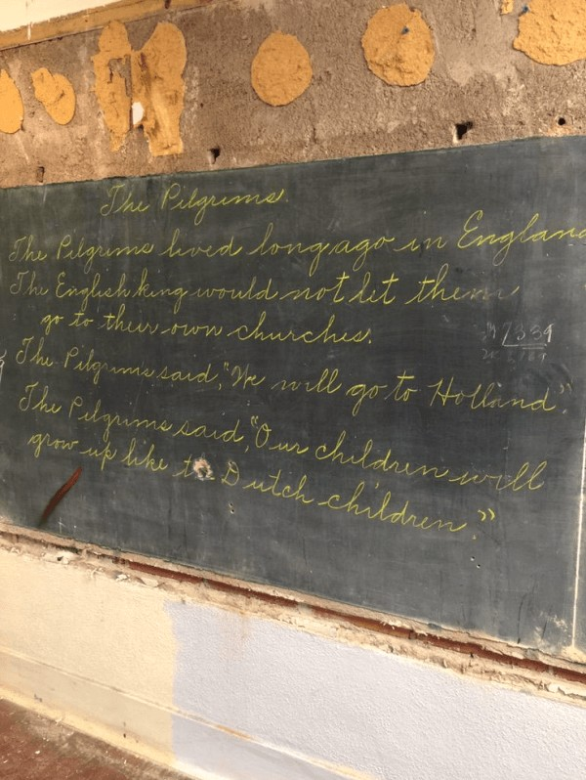
But these boards actually predate Principal Kishore’s mother by 13 years. Two dates were found on the boards: November 30, 1917, and December 4, 1917.
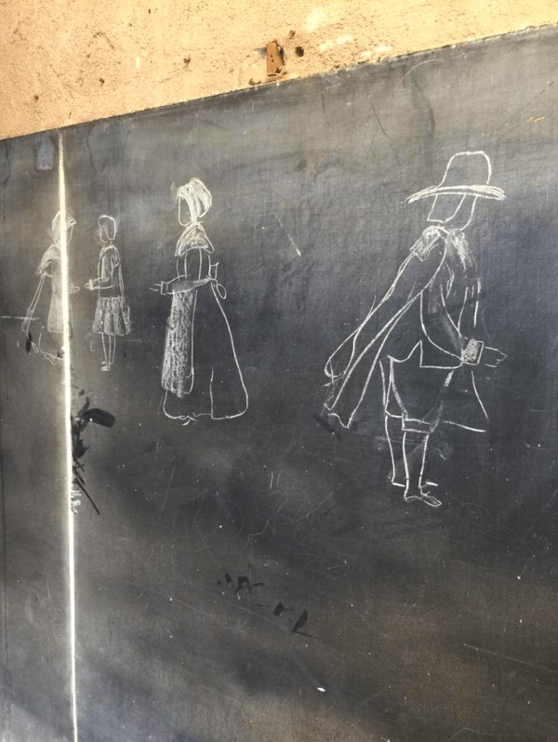
Some of the writings and drawings were done by students, while others were made by teachers — but i’s not always clear whose is whose.
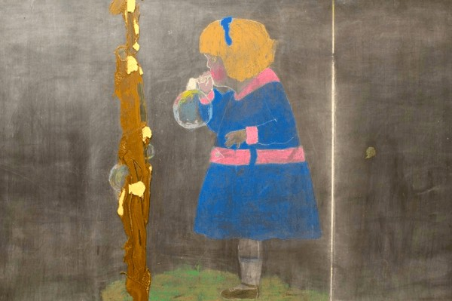
Regardless, the work is a striking look into days long gone. While reading the boards — like this one listing “My Rules To Keep Clean” — the past comes alive in a very personal way.
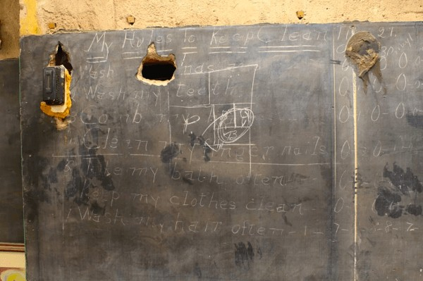
English teacher Cinthea Comer told The Oklahoman, “It was so eerie because the colors were so vibrant it looked like it was drawn the same day. To know that it was drawn 100 years ago… it’s like you’re going into a looking glass into the past.”
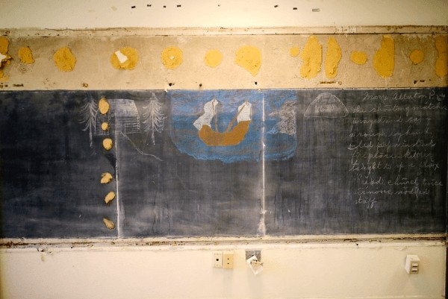
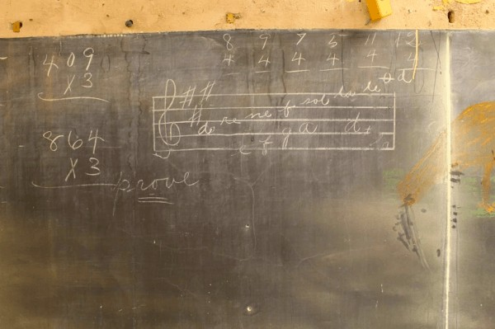
Built in 1895, Emerson High School has seen many renovations and improvements throughout the years — but nothing like this has ever been discovered.
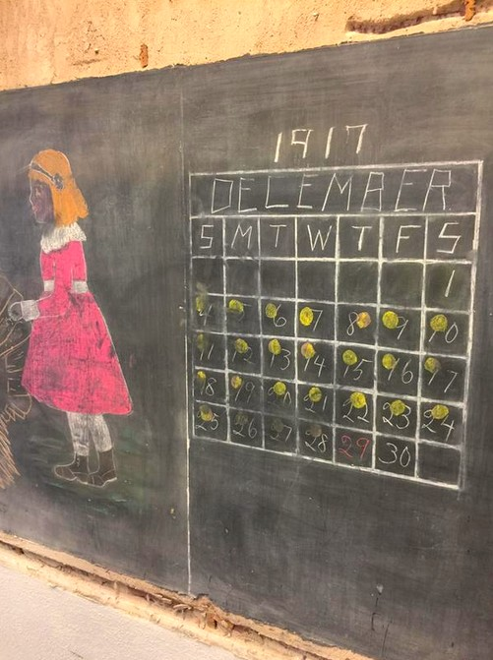
When removing old chalkboards in the past, contractors have only found broken pipes and wires, so this is a shocking surprise. Oklahoma City and the school district are now working to preserve these beautiful boards.
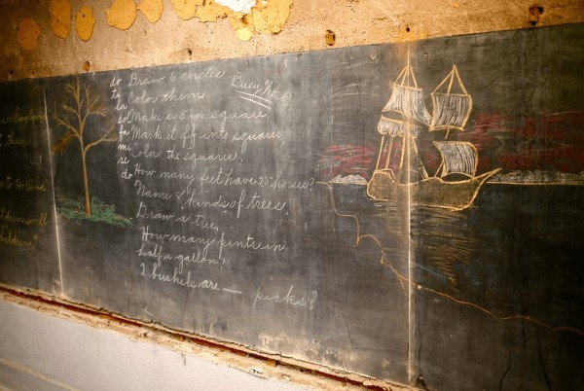
Hopefully, the spirit of these teachers and their students will be enjoyed for many years to come. Who knew that scribbles on a chalkboard could become such a precious piece of history.

